Sun, Moon, and Earth Jigsaw

Directions:

1. Organize Home Groups of 3-4 people.
2. Each Home Group member will become an Expert in one of areas
a. Group 1: Moon Phases (Reading 1, pages 2-5)
b. Group 2: Eclipses (Reading 2, pages 6-8)
c. Group 3: Moon’s Motion (Reading 3, pages 9-10)
3. Go to your Expert Group room
a. Group 1: Room 1
b. Group 2: Room 2
c. Group 3: Room 3
4. In your Expert Group (no more than 6 people in each Expert Group)
a. Read and discuss your focus idea.
b. Make sure that everyone fully understands the answer to your focus question (see text box below).
c. Be prepared to teach your Home Group so that they fully understand the answer to your focus question.
5. Return to your Home Group and teach each other so that everyone fully understands the answer to each of the three questions.

Three Focus Questions…

Group 1: Why do we see different phases of the moon? (Everyone should be prepared to explain and illustrate at least 4 phases.)
Group 2: What is the pattern of solar and lunar eclipses? What is happening in the system to create this predictable pattern?
Group 3: How does the Moon’s motion explain what we see from Earth (Moon’s surface and direction)?
Reading 1
U.S. Naval Observatory | Astronomical Applications Department

 |  | Phases of the Moon and Percent of the Moon Illuminated
  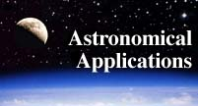

Note: For Moon phase information specific to a particular date, see  Dates of Primary Phases of the Moon,  Complete Sun and Moon Data for One Day,  Fraction of the Moon Illuminated, or  What the Moon Looks Like Today  in Data Services.  From any location on the Earth, the Moon appears to be a circular disk which, at any specific time, is illuminated to some degree by direct sunlight. Like the Earth, the Moon is a sphere which is always half illuminated by the Sun, but as the Moon orbits the Earth we get to see more or less of the illuminated half. During each lunar orbit (a lunar month), we see the Moon's appearance change from not visibly illuminated through partially illuminated to fully illuminated, then back through partially illuminated to not illuminated again. Although this cycle is a continuous process, there are eight distinct, traditionally recognized stages, called phases. The phases designate both the degree to which the Moon is illuminated and the geometric appearance of the illuminated part. These phases of the Moon, in the sequence of their occurrence (starting from New Moon), are listed below. | 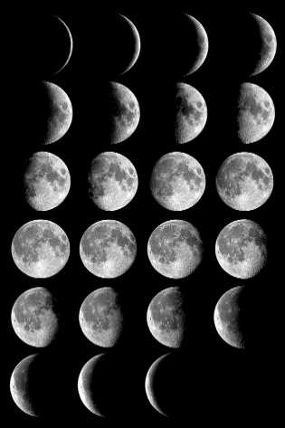  Copyright Antonio Cidadao. Used by permission. Click on picture to see large version.

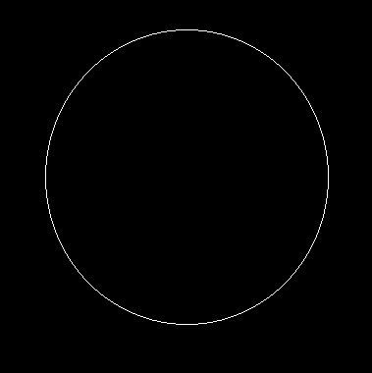 | New Moon - The Moon's unilluminated side is facing the Earth. The Moon is not visible (except during a solar eclipse).
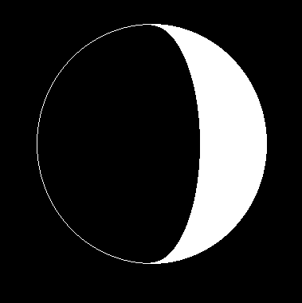 | Waxing Crescent - The Moon appears to be partly but less than one-half illuminated by direct sunlight. The fraction of the Moon's disk that is illuminated is increasing.
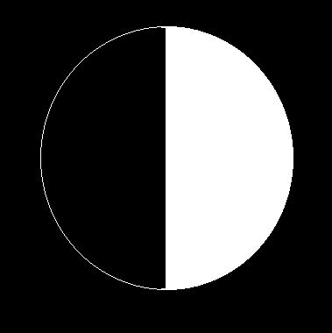 | First Quarter - One-half of the Moon appears to be illuminated by direct sunlight. The fraction of the Moon's disk that is illuminated is increasing.
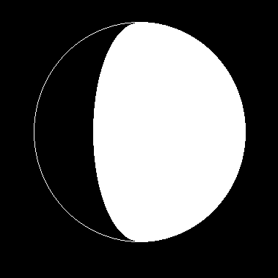 | Waxing Gibbous - The Moon appears to be more than one-half but not fully illuminated by direct sunlight. The fraction of the Moon's disk that is illuminated is increasing.
 | Full Moon - The Moon's illuminated side is facing the Earth. The Moon appears to be completely illuminated by direct sunlight.
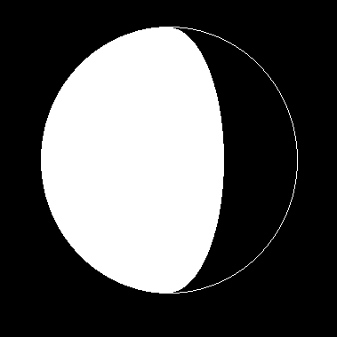 | Waning Gibbous - The Moon appears to be more than one-half but not fully illuminated by direct sunlight. The fraction of the Moon's disk that is illuminated is decreasing.
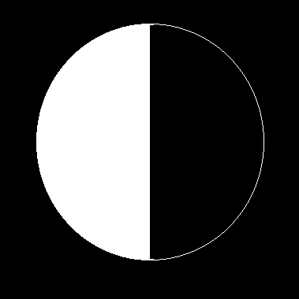 | Last Quarter - One-half of the Moon appears to be illuminated by direct sunlight. The fraction of the Moon's disk that is illuminated is decreasing.
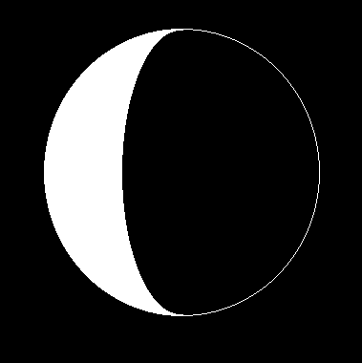 | Waning Crescent - The Moon appears to be partly but less than one-half illuminated by direct sunlight. The fraction of the Moon's disk that is illuminated is decreasing.
Following waning crescent is New Moon, beginning a repetition of the complete phase cycle of 29.5 days average duration. The time in days counted from the time of New Moon is called the Moon's "age". Each complete cycle of phases is called a "lunation".
Because the cycle of the phases is shorter than most calendar months, the phase of the Moon at the very beginning of the month usually repeats at the very end of the month. When there are two Full Moons in a month (which occurs, on average, every 2.7 years), the second one is called a "Blue Moon". See the article "Once in a Blue Moon" for the story of how the usage of this term has evolved (Ref: Philip Hiscock, Sky & Telescope, March 1999, pp. 52-55.).
The first time that the thin waxing crescent Moon is visible after New Moon (low in the evening sky just after sunset) marks the beginning of a month in the Islamic Calendar - see the FAQ Crescent Moon Visibility and the Islamic Calendar.
Although Full Moon occurs each month at a specific date and time, the Moon's disk may appear to be full for several nights in a row if it is clear. This is because the percentage of the Moon's disk that appears illuminated changes very slowly around the time of Full Moon (also around New Moon, but the Moon is not visible at all then). The Moon may appear 100% illuminated only on the night closest to the time of exact Full Moon, but on the night before and night after will appear 97-99% illuminated; most people would not notice the difference. Even two days from Full Moon the Moon's disk is 93-97% illuminated.
New Moon, First Quarter, Full Moon, and Last Quarter phases are considered to be primary phases and their dates and times are published in almanacs and on calendars. (Click here for a list.) The two crescent and two gibbous phases are intermediate phases, each of which lasts for about a week between the primary phases, during which time the exact fraction of the Moon's disk that is illuminated gradually changes.
The phases of the Moon are related to (actually, caused by) the relative positions of the Moon and Sun in the sky. For example, New Moon occurs when the Sun and Moon are quite close together in the sky. Full Moon occurs when the Sun and Moon are at nearly opposite positions in the sky - which is why a Full Moon rises about the time of sunset, and sets about the time of sunrise, for most places on Earth. First and Last Quarters occur when the Sun and Moon are about 90 degrees apart in the sky. In fact, the two "half Moon" phases are called First Quarter and Last Quarter because they occur when the Moon is, respectively, one- and three-quarters of the way around the sky (i.e., along its orbit) from New Moon.
The relationship of the Moon's phase to its angular distance in the sky from the Sun allows us to establish very exact definitions of when the primary phases occur, independent of how they appear. Technically, the phases New Moon, First Quarter, Full Moon, and Last Quarter are defined to occur when the excess of the apparent ecliptic (celestial) longitude of the Moon over that of the Sun is 0, 90, 180, and 270 degrees, respectively. These definitions are used when the dates and times of the phases are computed for almanacs, calendars, etc. Because the difference between the ecliptic longitudes of the Moon and Sun is a monotonically and rapidly increasing quantity, the dates and times of the phases of the Moon computed this way are instantaneous and well defined.
The percent of the Moon's surface illuminated is a more refined, quantitative description of the Moon's appearance than is the phase. Considering the Moon as a circular disk, the ratio of the area illuminated by direct sunlight to its total area is the fraction of the Moon's surface illuminated; multiplied by 100, it is the percent illuminated. At New Moon the percent illuminated is 0; at First and Last Quarters it is 50%; and at Full Moon it is 100%. During the crescent phases the percent illuminated is between 0 and 50% and during gibbous phases it is between 50% and 100%.
For practical purposes, phases of the Moon and the percent of the Moon illuminated are independent of the location on the Earth from where the Moon is observed. That is, all the phases occur at the same time regardless of the observer's position.

Source: http://aa.usno.navy.mil/faq/docs/moon_phases.html
Reading 2
The Sun and Moon
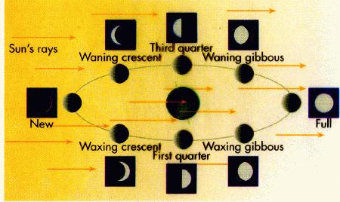
After the Sun, the Moon is the brightest object in the sky. Of course, the light we see doesn't originate on the Moon -- the Moon (like the planets) shines by reflected sunlight. [Note in passing: the Moon's surface is actually quite black. Only about 3% of the Sun's light which hits the Moon is reflected. But that's enough to light up our night sky.] The most prominent feature of the Moon's appearance in the sky is the Moon's phase. The Sun, of course, only lights up 1/2 the Moon -- the half that is facing the Sun. This doesn't always correspond to the half that faces the earth. In fact, if the Moon is on the same side of the earth as the Sun, we won't see the Moon at all. It's what we call a New Moon. If the Moon is on the opposite side of the earth as the Sun, then we have a Full Moon, and we can see the entire 1/2 that the Sun lights up. Note that this means we can tell time by the Moon. We normally tell time by the Sun. For example, if the Sun is near the meridian, then it's around noon; if it's setting then its around 6 p.m. However, as you can see from the diagram, the phase of the Moon tells us the angle between the Sun and the Moon. We see the Moon and we know the angle to the Sun, so we therefore know where the Sun is. Hence we know the time.
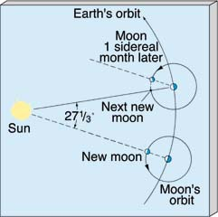
The Moon makes one trip around the earth (west-to-east) in a little over 27 days. But, once again, there is a difference between the one trip around with respect to the stars (the sidereal month), and one trip around with respect to the Sun (the synodic month). As we saw when considering the Sun, the synodic month (i.e., New Moon to New Moon) is longer, about 29 days.

The Moon does not orbit the earth in quite the same plane as the Sun -- the circle it takes on the sky it tiled from the ecliptic by about 5 degrees. Hence the Moon spends 1/2 its time just slightly north of the ecliptic, and 1/2 its time slightly south of the ecliptic (but always in a zodiac constellation). Twice a month, the Moon's path crosses the ecliptic. If the Moon happens to cross the ecliptic at the exact spot the Sun is, the Moon will block out the Sun's light, and we'll have a solar eclipse. (This does not happen often. The Moon is rather small and casts a small shadow. Consequently, it really does have to make a bull's eye with the Sun. Most of the time, its shadow misses the earth, and even when the shadow does reach the earth, it covers only a small area.) If the Moon blocks out the Sun completely, we call it a total solar eclipse. If it only blocks out a section of the Sun, then it's a partial solar eclipse. Finally, because the Moon's orbit around the earth is not perfectly circular, sometimes it will be perfectly aligned with the Sun, but still the solar disk will poke out around the edges. Then we have an annular solar eclipse. Because the Sun is so bright, unless it is totally eclipsed, it will be too bright to see with your eye. In fact, in most cases, you'll barely notice anything happening at all! Total eclipses are very rare, totally spectacular, and only last a couple of minutes. If you can, take a trip to see one. (But be prepared for crowds along the path of totality.)
About twice a year, the Moon will cross the ecliptic at a location exactly opposite that of the Sun. When this happens, the Moon will get in the Earth's shadow. This is a lunar eclipse. (The earth is substantially bigger than the Moon, so it's shadow is bigger. Hence lunar eclipses aren't all that rare.) Although the Moon is being eclipsed, it does not disappear completely. Some sunlight (mostly red light) makes it through the earth's atmosphere to the Moon. Consequently, when the Moon is eclipsed, we see it as a dull, red orb.
Source: http://www.astro.psu.edu/users/rbc/a1/lec3n.html

Reading 3
The Moon's Rotation
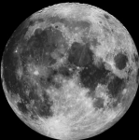
On the left we see a NASA photo of the moon. We always see the same side of the moon. So, it would seem that the moon does not rotate (spin on its axis), right? A surprising number of people are very insistent that the moon does not rotate.

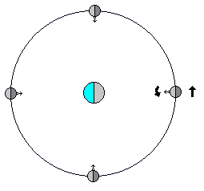
A person standing in one spot on the moon would see the earth in the same part of the sky (directly overhead, for the person in the diagram on the right), unmoving. But, he/she would see the sun appear to move around the sky in about 29 earth days. The person would correctly deduce that the moon has a solar day of about 29 earth days. This person would also see that the stars appear to move around the sky in about 27 earth days. Again, the person would correctly deduce that the moon spins on its axis once in about 27 earth days.

The moon definitely rotates. It just doesn't look like it, from where we stand.
The moon rotates at a constant rate. But, its distance from earth, and speed in its orbit, varies quite a bit. This means that we can see a little ways around the edge of the moon. And the rotational axis of the moon is tilted somewhat; so we can see a little beyond the Moon's north and south poles. So, over a period of time, we can see about 57% of the moon, from earth.
In the movie, Crocodile Dundee II, Paul Hogan travels back to Australia. In one scene, they show the moon. And it looks just like the moon looks in America. It should be upside down (South on top).
The rotation of the moon is, to some extent, a matter of definition, as it is not rotating with respect to us observers here on earth. But the above definition (with the moon rotating) is more consistent with other rotations in astronomy and geometry. An earth-centered universe is a myth which was disproved long ago.
Which Direction Does The Moon Move?
The moon rises in the east, and sets in the west. It moves from east to west, right? If you think about it, you should realize that much of the moon's apparent motion is due to the spin of the earth. The moon appears to go around the earth about once a day. And, you probably know that the moon actually takes about a month to go around the earth. That's where we get the word "month."
Why don't you perform a simple observation? Look at the moon, some night, and see where it is with respect to the stars (or with respect to the sun). You don't need to know the stars very well, but you probably want to ignore the planets (Venus, Jupiter, and Mars, mainly, as their motion complicates this observation). Night after night, the moon moves against the background of stars. See if you can tell which way the moon is moving, against the background of stars.
Another simple observation would be to keep track of when the moon rises (roughly) or sets from night to night. Does it rise later each night, or earlier, or what?
You will see that the moon moves west to east, fairly rapidly. See the following diagram:
Which way does the earth spin? Well, the stars, sun, moon, and planets all seem to be moving east to west. So the earth is spinning in the opposite direction, west to east. Hey, the moon is also moving west to east, coincidence? Well, the earth is moving around the sun from west to east. In fact all nine of the planets are moving around the sun from west to east. And, all of the planets, except Uranus (which is lying on its side) and Venus (which is spinning slowly backward), are rotating from west to east. And most of the moons, of the various planets, are orbiting their planets from west to east. And most of the asteroids are orbiting the sun from west to east.
It's not a coincidence. The Solar System started out as a cloud of dust and gas, and it was rotating from west to east. That's why most of its parts are still rotating and orbiting from west to east.
Source: http://www.jimloy.com/astro/moon0.htm

